Epic #1279103 BSSe Wireless: Device Financing Installment Loan Reporting & Recon Plus Reporting (QB #6545)

Document Attributes

SI Attributes | Value
EPIC ID | 1279103
Program | BSSe
EPIC SA Lead | Ashutosh Verma, AV912U
Epic Link | Epic 1279103: BSSe Wireless: Device Financing Installment Loan Reporting & BSSe-MoneyMap Reporting (QB #6545) - Boards (azure.com)
Other Attribute | Add additional attribute as needed

Revision History

Author/ATTUID | Revision Date | Version | Revision Description
Ashutosh Verma, AV912U | 02 Jul 2024 | 0.01 | Epic Reviewed on 26 Jun 2024  Initial Impact Analysis - Analyze phase
Ashutosh Verma, AV912U | 09 Jul 2024 | 0.02 | Added Draft Context Diagram
 |  | 1.0 | Feature SI
 |  | 1.x | Modifications based on iterations
Table of Contents

- 1. Problem Statement
- 2. Contributing Factors
  - 2.1 Assumptions, Constraints and Dependencies
- 3. End To End Solution
  - 3.1 Impacted Applications
  - 3.2 Context Diagram
  - 3.3 Solution Details
    - GEARS and Oracle ILS interface:
    - CFM, Oracle ILS and BSSe-MoneyMap interface:
    - Reconciliation
    - Reporting Data
    - Oracle ILS to DPG-Customer & Account Interface
- 4. Issue Log

1. Problem Statement

This epic contains the business requirements to pull data, insight into the data model, and reporting requirements related to installment loan reporting, bad debt related to installment loans, Management reporting (P&L) related to installment loans, aging reporting, and NFRs.
The installment loan subledger platform is a new solution to support capturing 100% of Direct and Indirect Channel installment transactions (financed devices). It will integrate operational and financial processes and controls for installment loan administration & accounting. This epic intends to establish foundational data capture for internal reporting purposes.

2. Contributing Factors

2.1 Assumptions, Constraints and Dependencies

A/C/D # | Description
Assumptions
A1
A2
A3
A4
A5
Constraints
C1 | Since all the features are not yet finalized so this in in time Solution and will get updated based on the bases on how features gets written to support requirement
C2 | The scope of this EPIC is to provide DPG-C&A. DPG-Order & Supply chain, DPG-Billing, DPG-Finance with data made available to ILS, IDP-Order graph, BSSe-RTB, CFM and IDP-CG as part of the EPIC BSSe Wireless: Device Financing – Installment Loan Setup, Billing, and Direct Fulfillment Activation. Any additional data required for reporting (Delta data) should be proposed as a change request (CR) or enhancement to the EPIC and is not included in the current scope.
C3
C4
Dependencies
D1 | Fraud Integration
D2 | Customer Account IP Status Changes
D3 | BSSe Device Financing - Accounting & Reconciliation (ADO #1206522)
D4 | BSSe Device Financing Installment Loan Setup/Billing/Direct Fulfillment Activation (ADO # 1279127)
D5 | BSSe Device Financing Installment Plan Pay up / Payoff (CAPM) (ADO # TBD)
D6 | BSSe SOX Compliance (SRT #1271)

3. End To End Solution

New Operating Model Solution Engineering

3.1 Impacted Applications

CTX Solution Intent does not address specific internal changes required of each system, nor does it address all detailed data elements needed to be passed to and from each system. The application design teams must detail these internal changes within their Technical Design Document (TDD), Application Interface Document (AID), Mid-Level Design (MLD), User Stories (US), and Interface Agreements.

Level of Effort | Definition
TSO | Test Support Only. No code or config impacts and no test case execution
Test | Test Case execution required by application
Easy | Minor coding changes, table updates, minimal interface updates, no workflow changes
Moderate | Interface updates, some workflow changes
Difficult | Significant workflow changes, multiple interface changes
Complex | New workflow required, new interfaces required, complex integration

MOTS ID | Application | Level of Effort | Impacts
31697 | BSSe-MMap/Recon Plus | Moderate | Development
30914 | BSSe-RTB | Non-Development | Non-Development
73 | CAPM | Easy | Non-Development
29287 | CDO Azure Cloud Services | Non-Development | Non-Development
13287 | CFM | Easy | Development
32412 | CorpFin-GL | Moderate | Development
32476 | CorpFin-Integration | Moderate | Development
31618 | DPG - Finance | Moderate | Development
7856 | FDW | Easy | Development
17784 | GEARS | Easy | Development
17985 | Oracle AR | Easy | Development
31372 | Oracle ILS | Moderate | Development
12590 | RECON PLUS | Easy | Development
31697 | BSSe-MMap/Recon Plus | Moderate | Development
31452 | BSSe-SkyFM | Moderate | Development
73 | CAPM | Easy | Non-Development
13287 | CFM | Easy | Development
32412 | CorpFin-GL | Moderate | Development
32476 | CorpFin-Integration | Moderate | Development
31204 | DPG - Billing | Easy | Development
31478 | DPG - Customer & Accounts | Easy | Development
31618 | DPG - Finance | Moderate | Development
31510 | DPG - Orders & Supply Chain | Easy | Development
17784 | GEARS | Easy | Development
31468 | IDP-Customer Graph Cloud | Test | Non-Development
31543 | IDP-Order Graph Cloud | Test | Non-Development
23488 | OCE | Test | Non-Development
17985 | Oracle AR | Easy | Development
31372 | Oracle ILS | Moderate | Development
18249 | ORACLE SCM | Easy | Development
12590 | RECON PLUS | Moderate | Development
30914 | BSSe-RTB | Non-Development | Development
29287 | CDO Azure Cloud Services | Non-Development | Non-Development
22597 | DATARTR | Config | Non-Development
7856 | FDW | Easy | Development

3.2 Context Diagram

Option 1: Reconciliation via MMAP

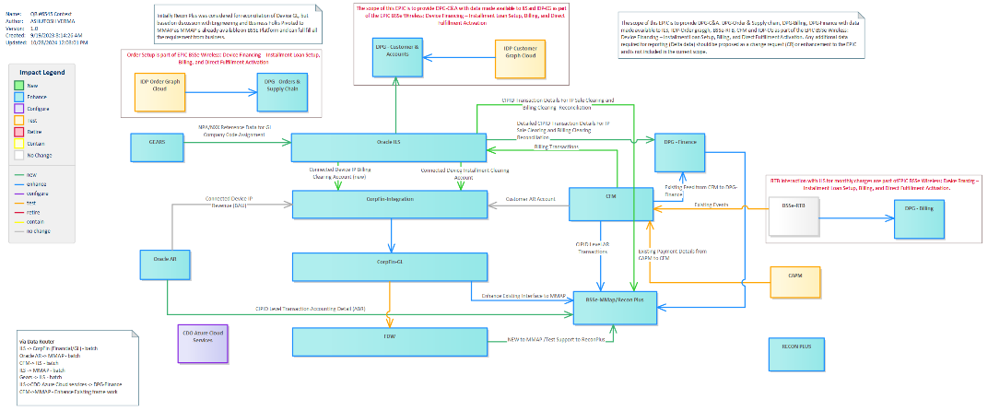

Option 2: Reconciliation via ReconPlus
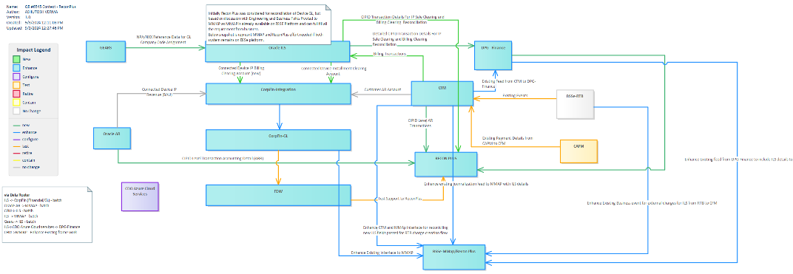

3.3 Solution Details
BSSE will be enhanced to provide capability to pull data, insight into the data model, and reporting requirements related to installment loan reporting, bad debt related to installment loans, Management reporting (P&L) related to installment loans, aging reporting, and NFRs.
The installment loan subledger platform is a new solution to support capturing 100% of Direct and Indirect Channel installment transactions (financed devices). It will integrate operational and financial processes and controls for installment loan administration & accounting. This Solution intends to establish foundational data capture for internal reporting purposes.
This EPIC will provide below listed applications capability to receive and transfer reporting and reconciliation data related to Installment loan subledger.

GEARS and Oracle ILS interface:
- GEARS will provide one time batch load via Data router according to AID specifications for all the NPA/NXX reference data to Oracle ILS.
- After one time load GEARS will provide batch extract again according to AID specifications to any changes on NPA/NXX reference data to Oracle ILS.
- GEARS send similar extract data to CFM on BSSE platform, Oracle ILS and GEARS need to revisit file sent to CFM to ensure if same file can be used by Oracle ILS team.
- During AID discussion if GEARS and Oracle ILS identify they could not use same file ( GEARS and CFM interface NPA/NXX reference Data) due require additional fields required by Oracle ILS, then GEARs and Oracle ILS need to work finalize either to update the existing Gears and CFM interface NPA/NXX reference data or create a new GEARS and Oracle Interface reference data file.
Note: If Gears and Oracle ILS finalize to go with new file b/w them, Oracle ILS and CFM needs to work together to ensure that journalization data going downstream system have similar information.
- Oracle ILS will be enhanced to consume NPA/NXX reference data received from GEARS and assign ILS to correct accounting while jounralization.

CFM, Oracle ILS and BSSe-MoneyMap interface:
- Oracle ILS post Instalment Loan Subledger billing data to BSSE-RTB system for billing purposes and RTB billed them for BSSE Account as defined in Epic#1279127 BSSe Wireless: Device Financing – Installment Loan Setup, Billing, and Direct Fulfillment Activation.
- Once RTB billed the charges posted by Oracle ILS, as per existing fields same information flows to CFM.
- Once CFM receives RTB Anniversary Billed Event,
  - CFM will post the Billing transaction based on Oracle ILS AID specification between CFM and Oracle ILS. This will as per solution and scope defined in EPIC BSSe Wireless: Device Financing – Installment Loan Setup, Billing, and Direct Fulfillment Activation.
  - CFM will post the Billing transaction to BSSe-MoneyMap based on AID specification between CFM and BSSe-MoneyMap.
  - CFM basically will post these transaction on daily basis when CFM is posting jornalization to CFAS and DPG-Finance system too.
  - During the AID discussion CFM and BSSe-MoneyMap needs to finalize if they can use the can use the existing extract journalization records which CFM passes to DPG-Finance or CFAS system or new extract batch load file need to be passed to BSSe-MoneyMap
  - Considering the size extract from CFM and BSSe-MoneyMap it is suggested to use batch extract on frequency finalized by application teams as per AID finalization discussion.
Note: During AID discussion if CFM and Oracle ILS finds that instead of batch file, API calls make more reasonable, they can go with API calls too as per agreement they come up during AID finalization.

Reconciliation
Note: Recon Plus was initially considered for the reconciliation of Device GL, However, after discussions with Engineering and Business stakeholders, we pivoted to MMAP, as it is already available on the BSSE Platform and meets all business requirements. Architecture provides both MoneyMap and ReconPlus as options; the decision on which to implement will be made by the engineering team. Context diagrams for both options are provided, but the solution outlines them on the same path.
- Oracle AR will publish daily Oracle AR(account receivable, revenue receivable) transactions extract from Oracle AR to BSSe-MoneyMap/RECON PLUS
- Oracle AR extract to BSSe-MoneyMap/RECON PLUS will contain BSSe IP transactional AR extract for new sales/ returns for on all of the sales/returns completed for a given day.
- Oracle AR extract will contain all the records for whom Oracle AR has received Shipping/return notification from SCOR on that day. That is Shipment/return of an equipment financed on BSSe platform results in creation of AR transaction within Oracle AR and will be part of mentioned extract
- Oracle AR and BSSe-MoneyMap/RECON PLUS transfer this extract as batch file via DataRouter, following the existing interface both application use to transfer legacy account transaction.
- BSSe-MoneyMap/Recon Plus will receive CIPID Transaction Details For IP Sale Clearing and Billing Clearing Reconciliation from Oracle ILS
- BSSe-MoneyMap/RECON PLUS should be able to consume the extract received from Oracle AR and perform reconciliation between extract received from Oracle AR and Oracle ILS.
- These extract from Oracle AR contain one time record either when equipment is shipped or when it is returned back, used for sole purpose of booking the amount of device on Account which customer owns and then Oracle ILS clears the amount based on monthly instalment for the device.
- Oracle ILS and BSSe-MoneyMap/RECON PLUS need to finalize AID based on the direction/guidance given by business for the required fields during design phase.
- Based on information received from upstream system Reconciliation tool (BSSe-MoneyMap/ Recon Plus ) should
  - Ensure that Customer Installment Plan ID (CIPID) details related to Installment Plan clearing account financial transactions are collected.
  - Ensure the financial data (journalized over a given month) that is sent from each subsidiary system recording financial transactions ties to the GL balances for that month PRIOR to loading the files into the Reconciliation tool.
  - Ensure all required data fields are populated and provided in the file sent from each subsidiary system PRIOR to loading the files into the Reconciliation tool.
  - Support ability for the Reconciliation tool to reject the entire detail feed
  - Source system should then re-validate the financial data and re-send the correct detailed feed
  - Support ability to generate a report that details the dollar amount per individual source system, and association to the FDW general ledger balance for that source system.
  - Support ability to derive the Reconciliation Type value for each individual transaction.
    - Reconciliation Type values should be made configurable
  - Ensure the data from all Direct Channels is integrated into the reconciliation process.
  - Ensure the data from all systems is correctly loaded and mapped into Reconciliation tool.
  - Support the ability for business users (financial controllers) to configure the Reconciliation Matching rules.
    - Enable configuration of matching rules for:
      - linking outbound and inbound transactions via a) common identifier and b) amount
      - matched transactions with a financial variance on the common identifier
      - matched transactions with an amount variance
      - transactions that cannot be matched
  - Support monthly reconciliation aging reports for Installment Sale, Billing, and Pay Up/ Pay Off Clearing Accounts.
  - Data elements included in this report must be configurable.
  - Automating the Reconciliation Matching rules will need to be revisited in future scope. With BSSe-MMAP, differences can be identified, but BSSe-MMAP is not responsible for fixing these issues. Instead, BSSe-MMAP can report the discrepancies to the SOR application, which will then correct and fix the issues as needed and send new transactions for reconciliation.
    - Since BSSe-MMAP performs reconciliation at every step within the BSSe platform, reaching a mismatch at this stage is a very rare occurrence. We will need to address and provide solutions based on real-time issues as they arise on the BSSe platform.
  - Recon Plus has indicated that it can support the automation of reconciliation matching for inbound and outbound transactions against any unmatched outstanding transactions. However, this requires an agreement with the Recon Plus and CFAs systems to accept changes made by Recon Plus, which is not the system of record in this case. Engineering will need to discuss and finalize this item if they decide to proceed with the Recon Plus route for ILS reconciliation.

Reporting Data
Note: The scope of this EPIC is to provide DPG-C&A. DPG-Order & Supply chain, DPG-Billing, DPG-Finance with data made available to ILS, IDP-Order grapgh, BSSe-RTB, CFM and IDP-CG as part of the EPIC BSSe Wireless: Device Financing – Installment Loan Setup, Billing, and Direct Fulfillment Activation. Any additional data required for reporting (Delta data) should be proposed as a change request (CR) or enhancement to the EPIC and is not included in the current scope.

Oracle ILS to DPG-Customer & Account Interface
- Oracle ILS will be enhanced as needed to provide loan setup data for customer and account to DPG-C&A in batch file based on interface agreement between teams.
- DPG-C&A will enhance to subscriber existing IDP-CG events to receive Simple wireless data along with loan setup summary information stored in IDP-CG domain for BSSe accounts

IDP-Order Graph and DPG-Order & Supply Chain Interface
- DPG-Order & Supply chain will be enhanced as needed to consume existing IDP-Order graph events for Wireless account on BSSe platform and store their loan setup related information too at their end.

BSSE-RTB and DPG-Billing Interface
- DPG-Billing will be enhanced as needed to consume existing BSSE-RTB events for Wireless account on BSSe platform and store their monthly loan payment related information too at their end.

CFM, Oralce-ILS and DPG Finance Interface
- CFM to DPG - Finance existing interface for jornalization will be enhanced as needed to support addition of new fields if needed due to additional information received as part of ILS billed records received from Oracle ILS to RTB to CFM.
- DPG-Finance will be enhanced to Detailed receive and store CIPID Transaction Details for IP Sale Clearing and Billing Clearing Reconciliation from oracle ILS.
- Oracle ILS and DPG-Finance need to finalize AID based on the direction/guidance given by business for the required fields during design phase.

Based on information received from upstream system DPG system should be able to provide data to
- Support the ability to create and maintain ad-hoc reporting for data related to the sales and lifecycle of connected device installment loans
  - Reporting tools must support manual ad-hoc reporting with a near real-time data feed to be sent to applicable reporting applications/data warehouses.
  - Support the ability to report on Bad Debt data related to the sale and ongoing maintenance lifecycle of connected device installment loans. Specific reporting capabilities should include:
  - Net Note (Net of Promotions and Gli) by Origination Month. Reporting should support ability to configure a specific time period.
  - The unique identifier (CIPID) of the loan to be added to the biller financial journal.
  - Support the ability to include data related to the sale and ongoing maintenance lifecycle of connected devices in the P&L reporting for a specified set of business users.
  - Ensure that the data elements required (as identified by business) for all financial transactions related to ILS contracts and the ILS data model are exposed and sent to applicable reporting applications/data warehouses..
  - Ensure that the data related to the varying types of installment plan contracts at the subscriber level is sent to the applicable reporting applications/data warehouses.
  - Reporting: Installment Loan Audit
  - Enable BSSe product managers to support audit requests related to installment loan status during the loan lifecycle.
  - Provide ability to view historical details and current status of connected device installment loans.
  - Support the ability to send data to applicable reporting applications/data warehouses for installment loans that are not in “Active” status at the end of the business day, or within 24 hours of entering that status.
  - Fallout (“stuck” status) processing - Identify when system errors result in a new installment loan not progressing beyond "Approved" status after a configurable period of time. Send those loan details to data warehouses and fallout systems for analysis and resolution.
  - Reporting: Activation Aging
  - Support an aging report for non-activated devices/CTNs.
  - Aging report can be created during a configurable time period.

4. Issue Log

No | Date | Title | Description

